Area Code Overlay Approved for the 909 Area Code

Get ready to change the way you dial your local calls! To ensure a continuing supply of telephone numbers, the new 840 area code will be added to the area served by area code 909. This process is known as an area code overlay. The overlay will require all calls to be completed using a new dialing procedure.
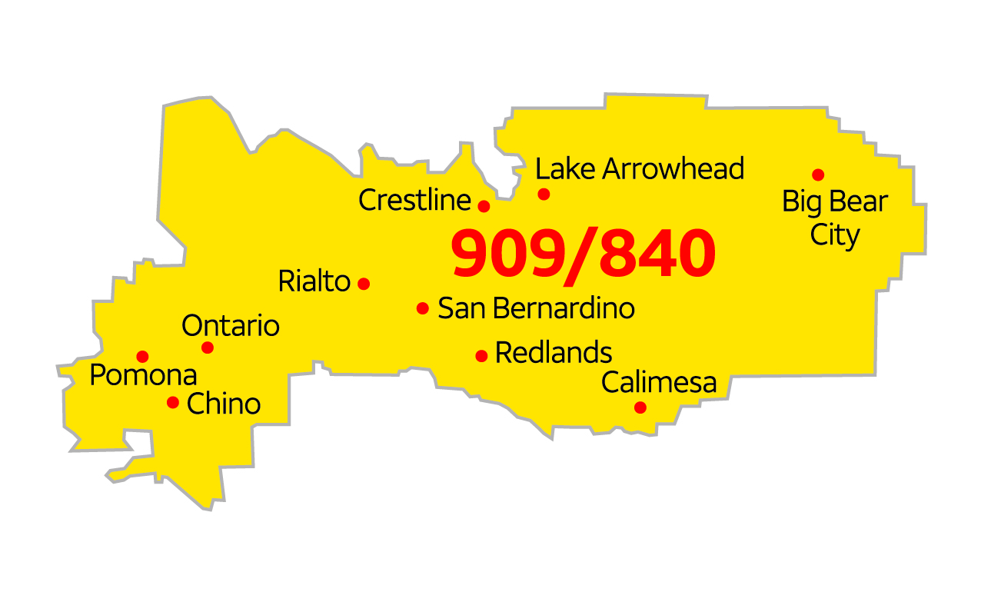

What is an area code overlay?
An area code overlay is the addition of another area code (840) to the same geographic region served by an existing area code (909). An overlay does not require customers to change their existing area code but does require customers to use a new dialing procedure to complete telephone calls. When an overlay is implemented, customers must dial “1” followed by the area code and the seven-digit telephone number to complete every call, including calls within the same area code.

Who will be affected?
All customers who have a 909 or 840 area code telephone number will be affected. The 909 area code serves the southwestern portion of San Bernardino County, the eastern portion of Los Angeles County and small portions of Orange and Riverside Counties. The 909 area code serves the cities of Big Bear Lake, Calimesa, Chino, Chino Hills, Claremont, Colton, Diamond Bar, Eastvale, Fontana, Grand Terrace, Highland, Industry, La Verne, Loma Linda, Montclair, Ontario, Pomona, Rancho Cucamonga, Redlands, Rialto, San Bernardino, San Dimas, Upland, Walnut and Yucaipa. The new 840 area code will serve the same geographic area currently served by the existing 909 area code.

What will be the new dialing procedure?

To complete calls from a landline phone, the new dialing procedure requires anyone with a 909 or 840 area code to dial 1 + area code + telephone number. This means that all calls in the 909 area code that are currently dialed with 7 digits will need to be dialed with 11 digits using the new 1 + area code + telephone number dialing procedure.

To complete calls from a cellular or mobile phone, callers may dial area code + telephone number or 1 + area code + telephone number whenever placing a call from a phone number with the 909 or 840 area code.

When will the change begin?
Beginning July 25, 2020, you should begin using the new dialing procedure whenever you place a call from the 909 area code. If you forget and dial just 7 digits, your call will still be completed.

Beginning January 23, 2021, you must use the new dialing procedure, as described above for all calls, even for local calls. On and after this date, if you do not use the new dialing procedure, your calls will not be completed, and a recording will instruct you to hang up and dial again using the new dialing procedure.

Beginning February 23, 2021, new telephone lines or services in the 909 area may be given numbers from the new 840 area code. Anyone that receives an 840 area code telephone number must use the new dialing procedure described above.

What will you need to do?
In addition to changing your dialing procedure, all services, automatic dialing equipment, or other types of equipment that are programmed to dial 7 digits will need to be reprogrammed to use the new dialing procedure. Some examples are life safety systems and medical monitoring devices, PBXs, fax machines, Internet dial-up numbers, alarm and security systems or gates, speed dialers, call forwarding settings, voicemail services, and other similar services or equipment. You may also want to check your personal and business stationery, checks, advertising materials, websites, contact information, and personal or pet ID tags to ensure the area code is included in the telephone number.

What will remain the same?
- Your telephone number, including current area code, will not change.
- The price of a call, coverage area, or other rates and services will not change due to the overlay.
- What is a local call now will remain a local call regardless of the number of digits dialed.
- You can still dial just three digits to reach 911, as well as 211, 311, 411, 511, 611, 711 and 811.

Who may you contact with questions?
If you have any questions regarding information provided in this notice, please call Service Provider at SP Phone Number or access the following websites for more information: (service provider’s website) or www.cpuc.ca.gov/909areacode/.

